**Assignment no-2**

1)Create a Branch and move to that branch

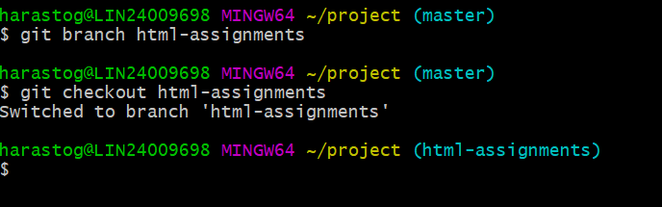

2)Make small changes on them and commit the file.

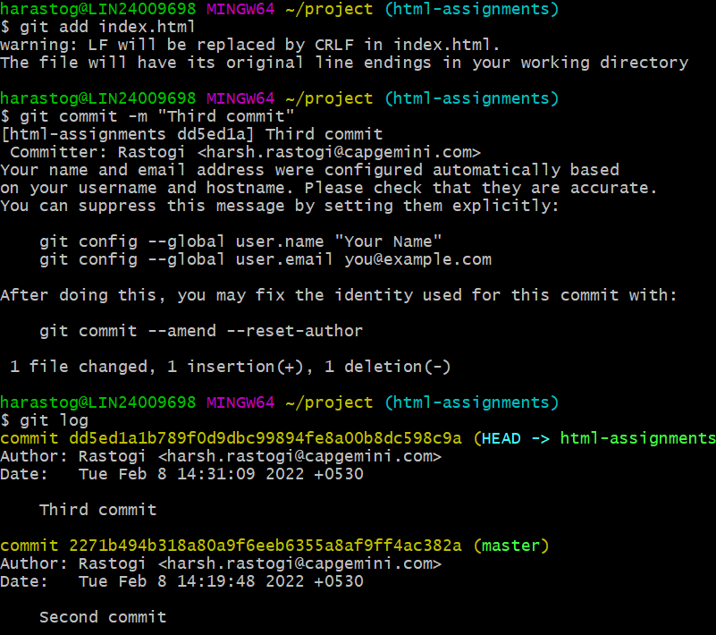

3) Switch to master branch

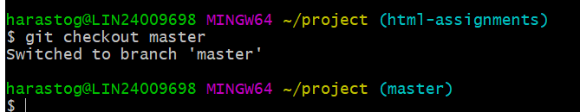

4) Make minor changes into README.txt file & commit those changes into master.

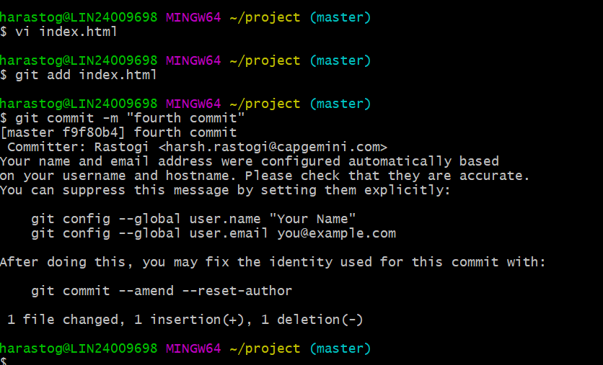

5) Again switch to 'html-assignments' branch and . Make minor changes into few files belonging to 'html-assignments' branch and commit the changes.

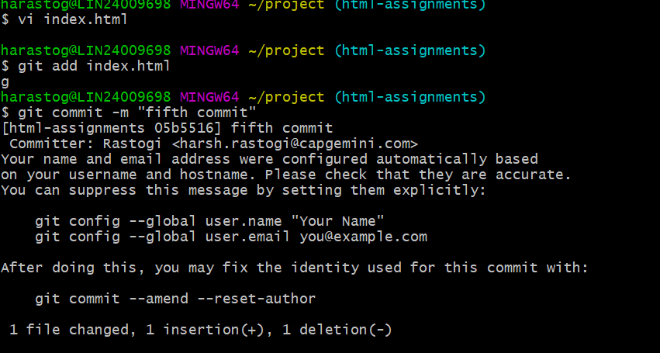

6) Switch to master

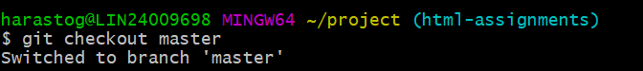

7) Merge 'html-assignments' branch into master. Confirm all html assignments are shown in master.

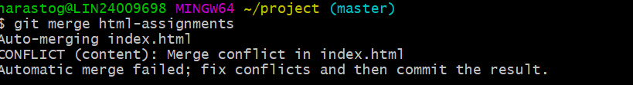

8) Finally delete the 'html-assignments' branch.

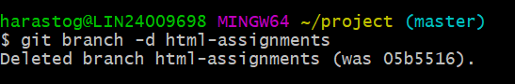

GIT logs-

